* **Activity 8:**

Using the ALL Operator in Multiple-Row Subqueries

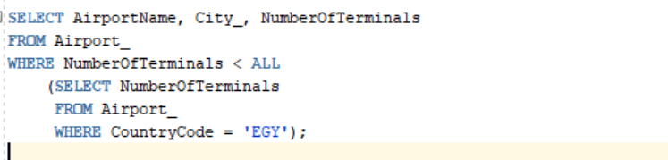

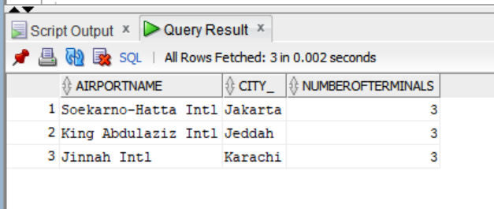OUTPUT: